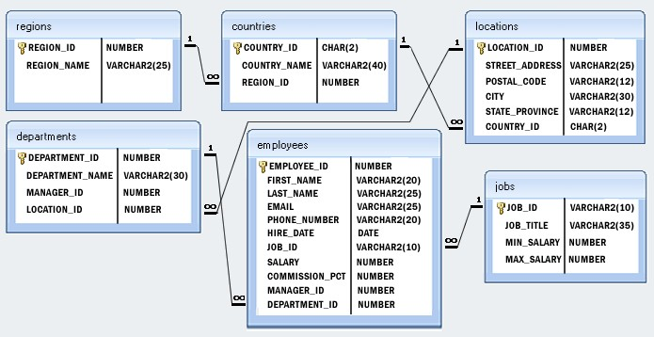

Create Above Data base with appropriate primary and foreign key

Note: 1 means primary filed and infinity symbol means foreign key

Assignments

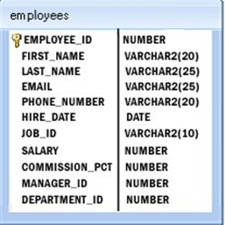

1. Write a query get all first name from employees table in upper case
2. Write a query to get the first 3 characters of first name from employee stable
3. Write a query to get the names (for example Ellen Abel, SundarAnde etc.) of all the employees from employees table
4. Write a query to get first name from employees table after removing white spaces from both side
5. Write a query to get the length of the employee names (first_name, last_name) from employees table
6. Find the employee count as per the hiringDate
7. Find the max salary from each dept and display in desc order.
8. Display employee name only first 3 lettera